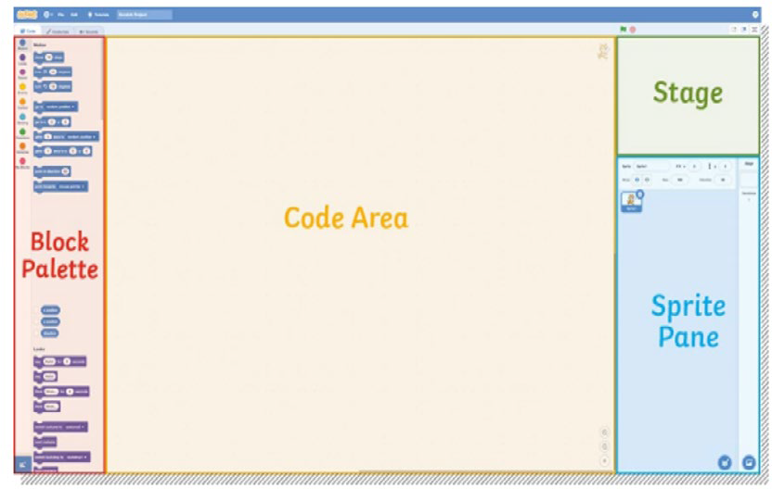
To break down existing algorithms into smaller parts to see what they want to do.
What happens as a result of actions or choices made within the game.
A piece of data that can be recorded in the memory of Scratch. A variable can be altered and changed.
A way to change the appearance of a sprite.
A set of sequenced instructions or rules for solving a problem or completing a task in a logical order.
To find, remove or correct errors in a computer program.
When a command or process is repeated.
repetition
consequence
variable
An image that can be shown on the Stage.
backdrop
costumes
sequence
The order in which a set of instructions is performed or carried out.
deconstruct
debug
algorithm
Coding with Scratch: Developing Games

Year 5
Key Vocabulary
What Is an Algorithm?

Algorithms on a computer are exactly the same as everyday algorithms. They are a set of sequenced instructions or rules for solving a problem or completing a task in a logical order.

Scratch Interface













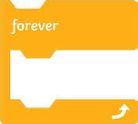
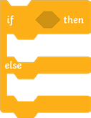


Circle - This tool allows you to draw circles or ovals.
This block makes the code inside the loop repeat continuously.
This block uses the input of a specified key to begin an algorithm.

Select - This cursor can be used to move an object, resize and rotate it.
Rectangle - This tool allows you to draw squares or rectangles.
Reshape - This tool can be used to bend or change shapes.
Eraser - This tool allows you to remove any drawings you have made.
Text - This tool can be used to type words onto a backdrop.
Line - This tool is used to draw straight lines.
Fill - This tool allows you to fill in an object.
Brush - This tool allows you to draw.

Key Blocks
This block starts an algorithm when the green flag is clicked.
This block determines the outcome of a condition.
This block detects if a sprite is touching a specific colour.
This block changes the backdrop to one from the drop-down menu.
Coding with Scratch: Developing Games

Year 5
Scratch Blocks
Scratch Paint Editor
There are nine categories of blocks in Scratch. Blocks are shaped like puzzle pieces as they fit and connect together vertically to create an algorithm.
Block Categories
Each block category has its own set of coloured blocks, which each have their own function.

